**CHAPTER ONE**

1. **INTRODUCTION**

An On-line discussion forum is a virtual place on the internet where conservations can take place and information can be shared more easily among a geographically dispersed group of people.

Discussion forums are typically created around a specific topic of common interest or for a specific user group around a particular piece of work (Simon 2000).

This present era has been termed to be an information age, an age where the demand for information has dramatically increase, the internet has been the most useful place for getting information nowadays, the use of search engines is one of the most useful, the internet is not just used for getting information but for also socializing and exchanging ideas and information, this has led to the development of several software and applications, ranging from the development of online communities and interactive applications.

Sylvia (2007) explains that, an online forum is a type of interactive website for holding discussions and posting user generated content, usually each conversation has its own screen, with the original posting at the top, and responses listed in reframe. A sense of virtual community often develops around forums that have regular users. It is an instance of interactive web. Forums differ from chat rooms and instant messaging because forum participants do not have to be online at the same time, they suit short posts, which request a response from others. This online forum can enhance campus-based activities; opportunities to support existing campus-based activities will be explored. For example faculty learning communities and workshop that are supported through the learning could be supported and promoted through the forum, exchange of expertise and services with other forums.

An online forum, or message board, is an online discussion site where people can hold conversations in the form of posted messages. They differ from chat rooms in that messages are at least temporarily archived. Also, depending on the access level of a user and/or the forum set-up, a posted message might need to be approved by a moderator before it becomes visible.

Luke (2003) explains, one good way to get users to return to your site is to offer Web forum, these can be used for purposes as varied as philosophical discussion groups and product technical support. Web forums are sometimes also called discussion board or threaded discussion groups, the idea of a forum is that people can post articles or question to them and others can read and reply to their questions. Each topic in a forum is usually called thread.

Study Group Discussion is refer to as a communicative situation that allows its participants to express views and opinions and share with other participants. It is a systematic exchange of information, views and opinions about a topic, issue, problem or situation among members of a group who share certain common objectives. (Margaret Rouse, 2011)

Study Group Discussion helps problem solving, decision making and personality assessment. Students need to participate in academic discussions to help them with their courses.

**1.1 Background to the Study**

Study group discussions are held by students to share ideas and explain to themselves in clear terms a subject area or course of study. It involves coming together of students physically and electronically to discuss and share ideas and information among themselves.

Some of the problems with this approach of holding group studies include time wasting, distractions, stress etc which can eventually discourage students from being committed to such group study meetings.

This project work is therefore carried out to develop on-line discussion forum. In order to facilitate efficient study group interactions and eradicate the challenges posed by the traditional approach to group studies for Computer Science Students of Osun State Polytechnic Iree.

**1.2 Statement of Problem**

Investigation has revealed that the traditional approach to group studying among Computer Science students of Osun State Polytechnic Iree is associated with the following problems;

1. Sharing of information, ideas among themselves
2. Discussing issues about their courses and finding solution to it by asking questions and posting answers to it

Hence, an Online Study Group Discussion Forum that is capable of sharing information, ideas and discussing about their courses was designed, implemented and evaluated in this project work.

* 1. **Aim and Objectives of the Project**

The project is aimed at developing an On-line Study Group Discussion Forum for Computer Science Students of Osun State Polytechnic. The specific objectives are:

1. To design an On-line Study Group Discussion Forum for Computer Science students of Osun State Polytechnic.
2. To implement the designed system using PHP and MYSQL.
3. To evaluate the performance of the developed system by computing it with the existing system.

**1.4 Significance of the Study**

The implementation of this project work will provide an easily accessible means of sharing knowledge among Computer Science students of Osun State Polytechnic Iree. It will also help to Students to be able to discuss, ask questions and post reply to questions asked by their colleagues.

**1.5 Scope of the Project**

There are several forms of On-line discussion forum such as Google Group Discussion and Whatsapp. This project focused on the development of an On-line forum for holding group study in Computer Science area.

**1.6 Research Methodology**

The method employed for carrying out this project work are as follows:

1. Establishment of a theoretical foundation for the project work through a sound review of relevant literatures on Research Based Online Study Group Discussion.
2. The design of an Online Study Group Discussion Forum by creating User interface and Administrator homepage for easy access of the users.
3. The implementation of the design system was done by using PHP and MYSQL database.
4. The evaluation of the performance of the newly developed system based on comparison of the existing system and the newly developed system based on accessibility, effective, and efficient.

**1.7** **Definition of Terms**

**Online community**: it is a virtual community that exists online whose members enables its existence through taking part in membership ritual. Many means are used in social software separately or in combination, including text-based chat rooms and forums that use voice, video text or avatars

**On-line discussion forum**: it is an online discussion site where people can hold conversations in the form of posted messages

**Security:** It is the degree of protection against danger, damage, loss, and criminal activity. Security as a form of protection is structures and processes that provide or improve security as a condition.

**Information:** It is any kind of event that affects the state of a dynamic system

**Message board:** It is an online discussion site where people can hold conversations in the form of posted messages

**Database:** It is a system intended to organize, store, and retrieve large amounts of data easily

**Query:** A specific set of instructions for extracting a particular data or information

**Repository:** It is a location where large number of information or data are kept or stored.

**Thread:** (sometimes called a *topic*) is a collection of posts, usually displayed from oldest to latest.

**CHAPTER TWO**

**2.0 LITERATURE REVIEW**

**2.1 General Overview**

On-line Discussion Forum is a form of electronic communication which facilitates interaction based on certain interests and characteristics. Discussion forum are media for social interaction, using highly accessible and scalable publishing techniques. Discussion forum use web-based technologies to transform and broadcast media monologues into social dialogues (Idakwo, 2011). An On-line discussion media network platform is one that provides a medium for interaction by groups of people making it easy to share information (such as lecture materials, pictures and ideas) across a circle of people or groups. Statistics has shown that the use of social network such as Facebook, Twitter and LinkedIn is on the increase most especially among young individuals, the crop of which are students of tertiary institutions (Ikhu-Omoregbe, 2012).

**2.1.1 History of Online Discussion Forums**

According to Idakwo (2011), Online discussion has been around since computers were first networked. One of the original intentions of the internet was to make it easy for scientists to collaborate. The most important early discussion forums were on USENET, which started in 1979. Discussion forums later became the base for many online communities. The most recognizable use of discussion forum was through innovative application, an online dialogue framework, created by Ward Christensen, a former IBM employee and Randy Suess. Initially, they envisioned a place where they could immediately contact their co-employees for announcements, i.e. meetings, reports, and other affairs, rather than making multiple phone calls, distributing memos, and the like. They were looking into creating a computerized bulletin board, which is why they named the program CBBS (Computerized Bulletin Board System). Soon enough, more and more employees contributed their ideas and comments in the said online community. That event was a momentous episode in the history of computer and internet. It was the birth of online social networking.

The CBBS platform was made known to other companies and has been used for specific

purposes. The Bulletin Board System expanded largely and began breaking into the mainstream

much sooner than it was planned to. It was during the rise of the Internet Service Providers in the

early 1990s when social networking sites began to flourish. Along with the availability of internet service to people, many people rummaged to have themselves acquainted with this new technology. With the fast response of people to the budding internet community, the bulletin boards which were usually used by companies have started to expand their roles by offering their service to more people around the globe. More and more people joined the online community with the innate goal of creating an identity in this space and at the same time exploring the vast place that is the internet. Because of this, many internet-savvy companies gave what people wanted- getting to know more people and sharing common interests and points of view; that is through websites where they can socialize, websites which are now referred to as social networking sites.

Social media attained a great measure of success with the launch of the then very popular friendster.com. Creator of Friendster, Jonathan Abrams concocted a perfect mix of popular features from earlier social networking predecessors. Friendster became an instant success and gathered about three million members who signed up in its early months of launch. As years passed, Friendster reached an overwhelming hundred million users from all over the

globe. With much demand from its users, Friendster unfortunately got out of hand and suffered

from too many glitches in the server. Today, Friendster has been announced as a newly owned entity of a Malaysian Company, and outshone by present social networking sites but still remains

to be patronized most especially in Asia.

The conception of myspace.com opened the internet users to vast opportunities of selfexpression which include wide control over a user’s profile content. Practically different people from all walks of life have dedicated pages in MySpace. In MySpace, users experienced the best of creating unique identities to show to the online world.

MySpace remained as the uncontested favorite among all the social networking sites until 2005when it met its future competitor in the market. Soon enough, MySpace created additional features like mobile applications in order to keep up with the latest trends in the online community; and at the same time be at par with the growing popularity of contemporary social networking sites, more specifically the next thing in line. (Chopra,2013).

Facebook started as a local social network made for the students of Harvard. It was developed by a sophomore, Mark Zuckerberg. Facebook was actually made by hacking Harvard’s database containing identification images of students. The initial idea was actually to compare the faces of students with images of animals, for entertainment purposes. However, due to the potentially damaging contents of the site, the creators decided to put it down before it caught the attention of school authorities.

The application was shut down, but the idea of creating an online community of students came to existence. The platform was then improved and sooner than they expected, Facebook was released in campuses other than Harvard. Thereafter, high schools were already starting to get attracted to the idea of having online communities, thus opening the website to the younger population. In 2006, facebook.com ultimately offered the opportunity to the rest of the world. As

2007 approached, the registrants reached an overwhelming digit-roughly a million dozen (Chopra, 2013).

Facebook has grown to become the biggest and most popular social networking site today with a

population of above 500 million active users.

**2.1.2 What is an Online Forum?**

Online forums provides a unique type of social environment that enables people to share and access information freely. Users can either start new topics or leave comments in the threads of existing topics. Usually, an online forum has tens or hundreds of distinct boards or communities. These boards or communities group hundreds to thousands of threads of similar related topics together. Because of the huge numbers of users and the high dynamics of online forums, this type of environment has a rich complexity (Vicente, 2008).

An Online forum is also a system designed for the discussion of topics, with each topic separated into its own area, called a thread. A thread is begun by a user writing a short document, called a post, which introduces the topic or asks a question about the topic (Liu, 2010). Internet

users search online forums, generally, for two types of information. Some of them search the forums for subjective information such as different viewpoints, opinions, emotions, evaluations,

etc., on specific problems instead of a single correct answer (Prakhar, 2012).

**2.1.3 Structure of an Online Forum**

An Online forum as a whole contains various categories (broad subject areas), which themselves contain forums (more specific subject areas) which contain topics (threads or discussions) which are made up of individual posts (where a user writes something) (VBulletin, 2014). It is arranged in a very unique way/form i.e. From Categories to subforums, from subforums to more subforums and from these subfolders to threads, where members can start their discussions or posts.

1. **Usergroups and Levels**: Usergroups are groups of users that divide the community into manageable sections board administrators can work with. Each user can belong to several groups and each group can be assigned individual permissions. This provides an easy way for administrators to change permissions for many users at once, such as changing moderator permissions or granting users access to a private forum. There are three major usergroups in a forum:

a. **Moderators**: They are individuals (or groups of individuals) who look after the forums from day to day. They have the authority to edit or delete posts and lock, unlock, move, delete andsplit topics in the forum they moderate. Generally, moderators are present to prevent usersfrom going off-topic or posting abusive or offensive material (Sylvia, 2007). Commonprivileges of moderators include: deleting, merging, moving, and splitting of posts andthreads, locking, renaming, stickying of threads, banning, suspending, unsuspending,unbanning, warning the members, or adding, editing, removing the polls of threads(VBulletin, 2014).

b. **Administrators**: They are members assigned with the highest level of control over the entire board. These members can control all facets of board operation, including setting permissions, banning users, creating usergroups or moderators, etc., dependent upon theboard founder and what permissions he or she has given the other administrators. They may also have full moderator capabilities in all forums, depending on the settings put forth by the board founder (Sylvia, 2007). These are individuals who have been assigned to manage a forum. They can also be referred to as forum owners. There are also forums where administrators relate to each other to share their knowledge.

c. **Users**: are individuals or members who have been given access to a forum or who have publicly registered to access the forum. These members do not have any special privileges unless otherwise given by the Forum Owner. Users can become Moderators or Administrators, if designated by the Administrator (IMS Global Learning Consortium, 2014).



Figure 2.1: IMS Global Learning Consortium Davis, B.G (2014).

This figure describes the arrangement and flow of communication on an online forum. It consists

of the Moderators, Forum Owners, the function they perform and the contents of the online forum (like Category, Topics and Messages).

2. **Post**: A post is a user-submitted message enclosed into a block containing the user's details and the date and time it was submitted. Members are usually allowed to edit or delete their own posts. Posts are contained in threads, where they appear as boxes one after another. The first post starts the thread; this may be called the TS (thread starter) or OP (original post).

Posts that follow in the thread are meant to continue discussion about that post, or respond

to other replies; it is not uncommon for discussions to be derailed (Beard, 2011).

3. **Threads**: A thread is started on some subject by an initiator. If they are interested in the subject of the thread, people post their opinions in reply posts. Because reply posts can reply to any preceding post, many branches (sub-threads) of discussion appear in a thread, and a thread ends up with a tree-shaped structure. We refer to this as a thread structure (Jangwon, 2009). A thread starts with the publication of a post, which in turn triggers an amount of activity in the form of comments (Vicenc, 2008). Threads are very important concepts in conversations on online forums.

**2.1.4 Features of an Online Forum**

The ability of online forums to be able to submit threads and posts brought the invention of new web technologies/features. In this project, some of these under-listed features will be used like private messages and emoticons. These are some standard features of an online forum:

1. **Tripcodes and Capcodes**: In a tripcode system, a secret password is added to the user's name following a separator character (often an octothorpe). This password, or tripcode, is hashed into a special key, or trip, distinguishable from the name by HTML styles. Tripcodes cannot be faked but on some types of forum software they are insecure and can be guessed (cave76, 2009).

2. **Private Messages**: There are three reasons for this; you are not registered and/or not logged

on, the board administrator has disabled private messaging for the entire board, or the board administrator has prevented you from sending messages. Contact a board administrator for more information (Cave76, 2009).

3. **Attachment**: An attachment is a file or image uploaded to go with a post. It can be a convenient way for members to share documents and photos. The administrator sets who can attach files, how many per post, how large, and what types and size they can be in the Attachments and Avatars center (SMF Online Manual, 2013).

4. **BBCode and HTML**: It is not possible to post HTML on this board and have it rendered as HTML. Most formatting which can be carried out using HTML can be applied using BBCode instead (Cave76, 2009).

5. **Emoticon**: Emoticons are essentially textual representations of oral discourse markers, generally utilized to convey a writer’s sense of emotion and involvement. It is also a mode of representing a writer’s feelings in communication. (Halvorsen, 2012)

6. **Poll**: As with posts, polls can only be edited by the original poster, a moderator or an administrator. To edit a poll, click to edit the first post in the topic; this always has the poll associated with it. If no one has cast a vote, users can delete the poll or edit any poll option. However, if members have already placed votes, only moderators or administrators can edit or delete it. This prevents the poll’s options from being changed mid-way through a poll (Cave76, 2009).

7. **RSS and ATOM feeds**: The RSS (Rich Site Summary and Really Simple Syndication) feed is not human readable. It is an XML format which is designed to be read by machines rather than humans. There are different versions of RSS in use. RSS 2.0 is the most common. It is used for news/blog feeds as well as for Podcasting. A newer format, called Atom, is a more standardized way of providing XML content updates. However, it has not gotten wide acceptance yet outside of the blog communities(Cave76, 2009).

8. Other Features include avatars, ignore lists, subscriptions and cookies.

**Definition of Other Terms**

a. **Lurking**: Lurking is a slang term for when an individual reads a message board without posting or engaging with the community. Lurking is sometimes encouraged by forum moderators as a way for new members to get a sense of the community and etiquette before participating. Lurking also may occur if a user simply wants to get some information without adding to the discussion. A person lurking on a message board or other online community is referred to as a lurker (Janssen, 2010).

b. **Sticky topics**: These are topics that stay at the top of the forum they are posted in and do not get bumped down as new topics are posted. Often, sticky topics are used to post a forum FAQ or forum rules, so new users will always find these at the start of the forum topic list (Maurice, 2011).

**2.1.5 Applications of Online Forums**

The world has given way to some great advancement on the internet, which has brought about the solution to different problems. In this context, online forums have served as “Q&A” web application; where individuals with any question about any topic can be answered, and a social network; where groups are formed and interactions are made.

Online Forums have been applied in different spheres of the internet. These are the following applications of online forums today:

1. **Learning in schools through student interactions**: Online forums have served as platforms for students to communicate with their fellow classmates, lecturers and other edistance learning students. It has created e-learning opportunities for schools, which are having issues with student interactions within the class (Ikhu-Omoregbe, Halvorsen,Kadir,2012).

2. **Discussions:** Online forums have also facilitated different forms of discussions in schools, organizations and on other larger environments. For example, students given assignments over the holidays can ask for assistance and still receive their feedbacks. They also provide a means to interactively participate in discussions or obtain/provide answers to questions; the vast volumes of data contained in forums make them a valuable resource for “support sharing” (Xue, 2007) (Mark, 2002) (Li, 2011).

3. **Business Marketing:** Organizations have started to make use of online forums for finding new customers or gaining insights from those they already have. Online forums can benefit business in several ways like crowd sourcing service and support, consumer research, social CRM (customer relationship management), etc. Online forums have created the opportunity where companies and customers can talk and it may even escalate to the manager of that company (Inc, 2010) (Belicove, 2012).

4. **Decision-Making support:** It has been noticed that most online forum users have one decision or more to make at that point in time. This has led to scientists coming up with decision trees to understand the behavior of online forums. It can really be of use in schools, businesses, etc. (Xiaolin, 2009) (Ikhu-Omoregbe, 2012).

**2.2 Review of the Existing Systems**

Several platforms/systems have already been established as online discussion forums. This section will carefully review each of these existing systems in line with this project

**2.2.1 Google Groups**

Google Groups is a service from Google Inc. that provides discussion groups for people sharing common interests. It became operational in February 2001, following Google’s acquisition of Deja’s Usenet archive. A new and redesigned Google Groups was released in February 2012 with an updated user interface. A Help Center has also been created to cater for users with this new interface (Maluniu, 2013).

Google Groups have also served as a platform to create online and email-based groups. You can

either register/sign-up as a regular participant or an administrator. Users can either signup/ register as a regular participant or an administrator. The membership of Google Groups is at no cost at all, although as of 2013, a Google account is required. A new and redesigned Google Groups was released in February 2012 with an updated user interface. A Help Center has also been created to cater for users with this new Google Groups interface. A user can also decide the

type of access he/she wants by selecting public, announcement only, or restricted (Google Groups, 2014) (Lombardi, 2007).

Figure 2.2: Google Groups



This picture represents the Home Page of “Google Groups” forum. It represents a larger platform

for users with Google accounts to participate in the discussions with a link with my Google mail.

Source: (Google Groups, 2014)

**2.2.2 WhatsApp Messenger**

WhatsApp Messenger is a proprietary, cross-platform, encryptedinstant messaging client for smartphones. It uses the internet to send text messages, documents, images, video, user location and audio messages to other users using standard cellularmobile numbers.

As of February 2016, whatApp had a user base of one billion making it the most popular messaging application. WhatApp Inc, was founded in 2009 by Brian acton jan koum, both former employees of Yahoo. After Koum and Acton left yahoo in September 2007, the duo traveled to South America as a break from work. At one point they applied for jobs at Facebook but were rejected. WhatsApp was officially made available for PCs through a web client, under the name WhatsApp Web, in late January 2015 through an announcement made by Koum on his Facebook page: “Our web client is simply an extension of your phone: the web browser mirrors conversations and messages from your mobile device- this means all your messages still live on your phone”. The WhatsApp user’s handset must still be connected to the internet for the browser application to function. All major desktop browsers are supported except for Microsoft Internet Explorer. WhatsApp Web’s user interface is based on the default Android one.

As of January 21, 2015, the desktop version was only available to android, Blackberry and Windows phone users. Later on, it also added support for iOS, Nokia Series40, and Nokia S60 (Symbian).

.

**CHAPTER THREE**

3.0. **RESEARCH METHODOLOGY**

3.1. **The Research Approach**

The method for the research approach is as follows:

1. The design of the developed Research Based Online Study Group Discussion Forum system was carried out.
2. The developed of a Research Based Online Study Group Discussion Forum was implemented using Php and Mysql.
3. The developed system was evaluated by conjoin the existing system with the new system.

**3.2** **The Description of the developed of a Research Based Online Study Group Discussion Forum System**

The developed system consists of the User Homepage environment, User Registration Interface, The Administrator Homepage and The Administrator Delete User page described below in figures 3.1, 3.2, 3.3, and 3.4.

**3.2.1.** **The User Homepage Environment**

The User homepage environment is the first user interface displays at logon to both the existing users and the new users. It presents the general overview of the online group discussion forum, showing the various tabs, links and login section; register, etc as shown in figure 3.1

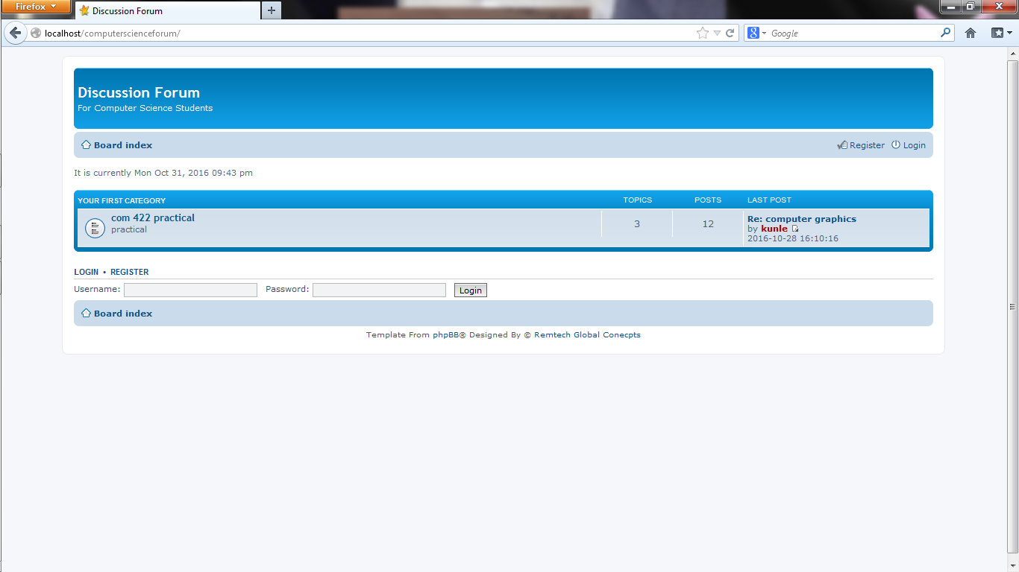

Figure 3.1 User homepage environment of the developed system

**3.2.2 The User Registration Interface**

Every User will have to click on the register link on the Home Page to access this page.

The user registration page is shown in figure IV on the next page.

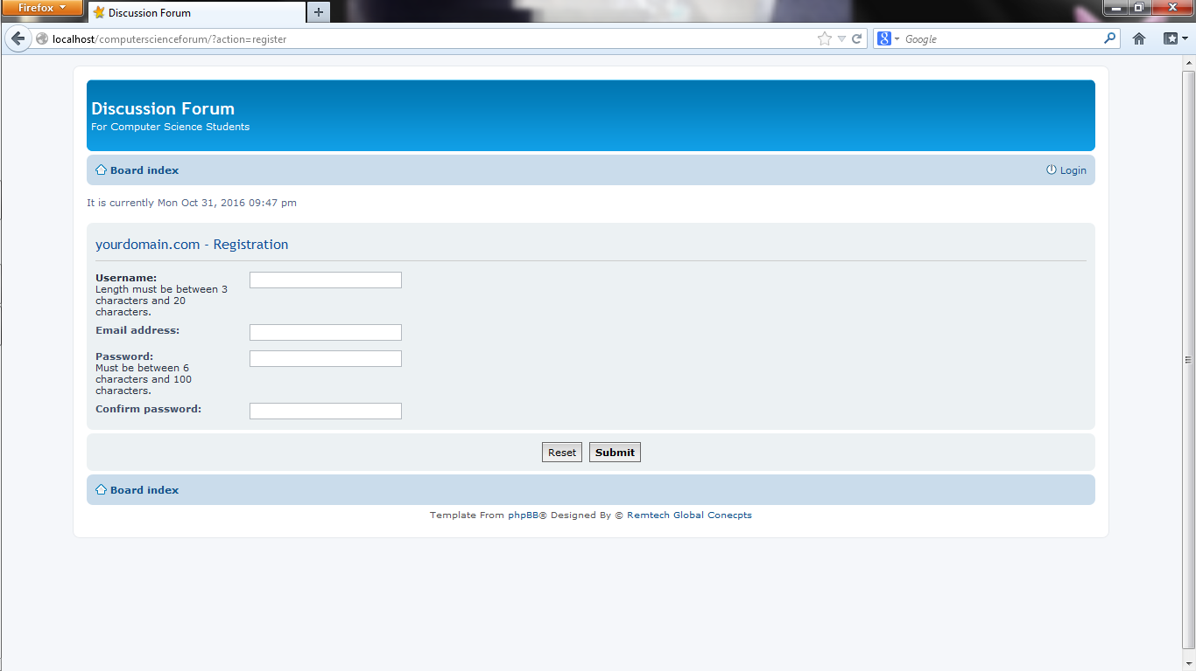

Figure 3.2 User registration interface

**3.2.3 The Administrator Homepage**

The Administrator is where the admin edit and delete the user’s accounts.

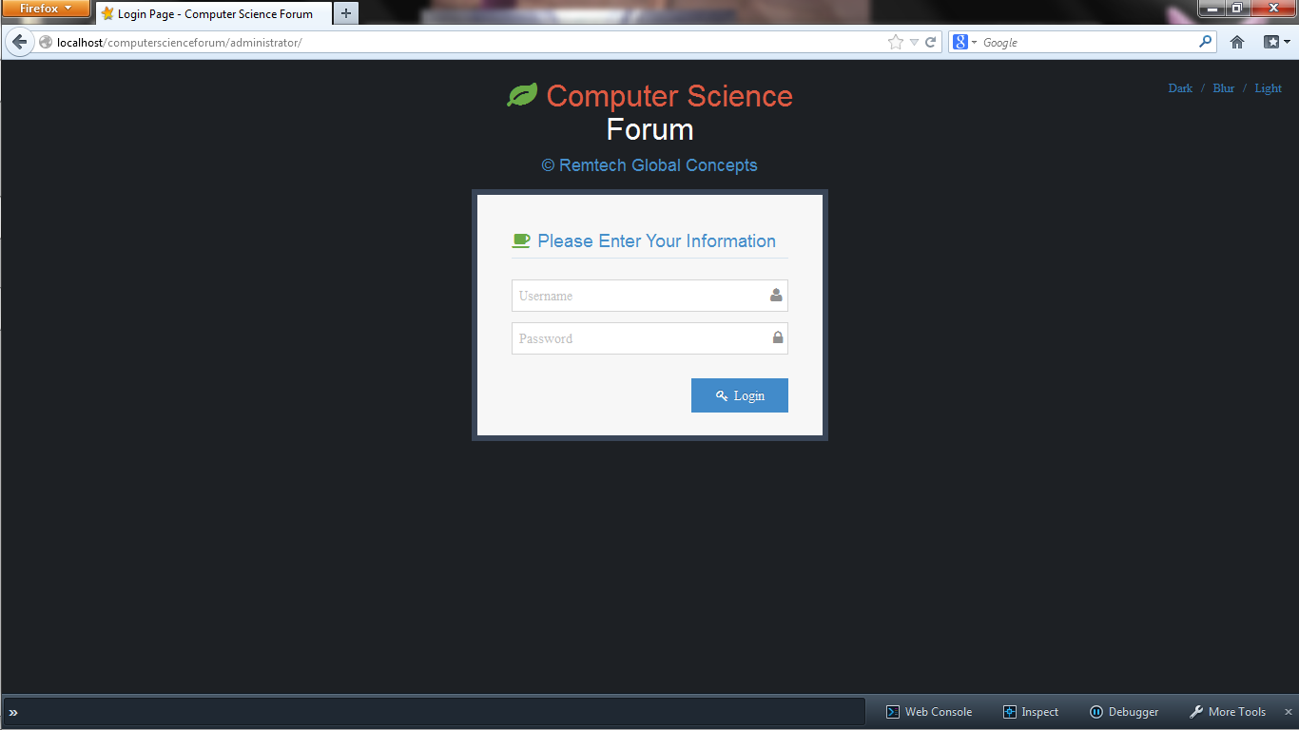

Figure 3.3 Administrator homepage

**3.2.4 The Administrator’s Delete User post page**

On this page, the Administrator can view and delete any users post as shown in figure 3.4

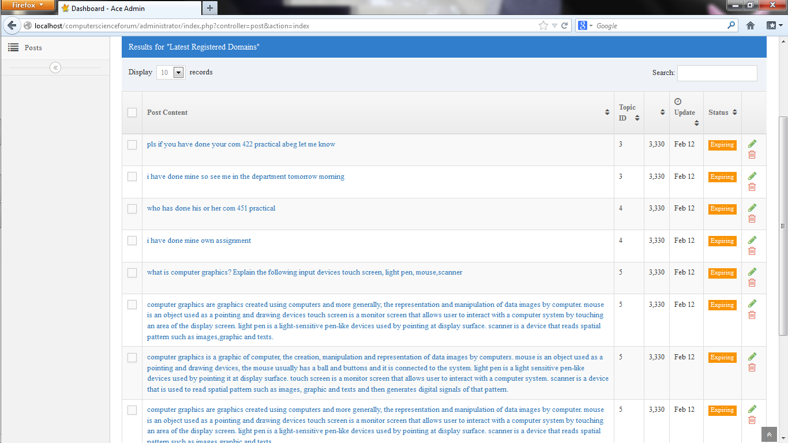

Figure 3.4 Administrator delete user post page

**3.3. System Implementation**

**Programming Language Used**

As earlier stated this system was built with PHP programming language and it was designed with HTML (using Flatlab as the design template). The database software used was MySQL managed by phpMyadmin. These tools and others that were used during this project are stated below:

1. **PHP**: It is a server-side scripting language, and is a powerful tool for making dynamic and

interactive Web pages quickly. It was the best choice of scripting languages to use for a very

flexible project as this. PHP was used to code the functionality of the system by leveraging

the Notepad++ framework. PHP version 5.3.8 was the version of use.

2. **HTML and CSS**: Hypertext Markup Language and Cascading Style Sheet are tools used in

development and creation of web pages that run mostly on web browsers. They were used to

develop the frontend design and user interface of the system.

3. **SQL:** SQL (structured query language) is a standard language for accessing databases. SQL

is used to access and manipulate data in: MySQL, SQL Server, Access, Oracle, Sybase, DB2,

and other database management systems.

4. **MySQL:** The MySQL database management system served as the database for building and

testing the system. It also served as the platform where all data used in the application could

be manipulated.

5. **phpMyAdmin**: This tool was used to manage the MySQL databases over the web and

locally on your computer. It provided an easy interface to carry out SQL operations on the

database. I worked with phpMyadmin version 3.4.5.

6. **vertrigo**: Vertrigo is an Open-source web server solution comprises of basic components such

as Apache HTTP, MYSQL, PHP or Perl languages. It was used in this project as the local

server in developing the system.

**3.3.1** **System Evaluation**

1. Evaluation Criteria
2. Evaluation Methodology

**3.3.2. Evaluation Criteria**

The developed system based on the following criteria:

* 1. Usability
  2. Accessibility

**3.3.3. Evaluation Methodology**

The developed system was evaluated by administering questionnaires on 20 twenty users. The completely filled copies of the questionnaires were collected and analysed.

**CHAPTER FOUR**

**4.0.** **RESULTS AND DISCUSSION**

**4.1. Result**

The result of the evaluation of the developed system is as presented in table 4.1, and 4.2 and figures 4.1, and 4.2

**Table 4.1.** The table of responses from users on usabilty of the system.

|  |  |  |
| --- | --- | --- |
| The designed system is easy to use | Frequency (users) | Percentage |
| Strongly Agree | 17 | 85% |
| Agreed | 2 | 10% |
| Disagreed | 1 | 5% |
| Strongly Disagree | 0 | 0% |
| Total | 20 | 100 |

Figure.4.1 Graphical Representation of the responses of the users on usability

**Table 4.2.** The table of responses from the users on accessibility of the system

|  |  |  |
| --- | --- | --- |
| The designed system is easy to access | Frequency (users) | Percentage |
| Strongly Agree | 17 | 85% |
| Agreed | 2 | 10% |
| Disagreed | 1 | 5% |
| Strongly Disagree | 0 | 0% |
| Total | 20 | 100 |

Figure .4.2. Graphical Representation of the responses of the users on accessibility

**4.2. Discussion**

Table 4.1 and figure 4.1 shows that 19 users out of 20 users agreed and only 1 disagreed that the developed system is easily accessible. Also table 4.2 and figure 4.2 shows that 19 out of 20 users agreed that the system is very fast in operation from the result shown in the table.

It is concluded that majority of the users agreed that the system is easy to access and fast in operation.

**CHAPTER FIVE**

**5.0. CONCLUSION AND RECOMMENDATION**

**5.1. Conclusion**

As the Online Study Group Discussion forum grows, online study group discussion forums like Computer Science Forum will be relevant to students in the computer science department. Even as other versions will be later developed, the activities and features on the site will increase because they will be built to meet the end-users requirements.

It is concluded from the result of the implementation that the developed system is usable, easily accessible and it provide a secured database system for Online Study Group Discussion Forum for Computer Science Students has been developed.

**5.2.** **Recommendation**

It is recommended that:

1. The developed system should be used for Computer Science Students of Osun State Polytechnic, Iree in order to share information and discuss issues among themselves.
2. The developed should be extended to provide access to all the students in the Polytechnic environment.

**REFERENCES**

Beard, U (2011, February 10). How to properly use an Internet Forum [READ NOW]. Retrieved

March5, 2014, from <http://www.bungie.net/7_> how -to-properly-use-an-internet-forum-READNOW/en/Forum/post?id=25155592&path=1

Belicove, M. E., (2012). 8 Do's and Don'ts for Marketing on Online Forums and Message

Boards. [Online] Available at: http://www.entrepreneur.com/blog/223900

[Accessed 27 March 2014].

Cave76, (2009, February 8). Learning about Internet forums. Retrieved March 5, 2014, from

<http://www.lymeneteurope.org/forum/viewtopic.php?f=8&t=2446>

Chopra, K., (2013, May 23). Social media today. Retrieved March 5, 2014 from

<http://socialmediatoday.com/karenn1617/1745751/effects-social-media-how-wespeak-and-write>Falls, J, (2012). Why Forums May Be the Most Powerful Social Media Channel for Brands.

Davis, B.G (2014, January 11). IMS Global Consortium. What is a Forum? Retrieved January 27

2014 http:// www.imsglobal.org/community/blog/help/english/what_is_a_forum.html.,

Halvorsen, R, Kadir, B, (2012). Linguistic Features in the Online Discussion

Forums. International Journal of Social Science and Humanity, 2(3), pp. 276-281.

Idakwo, L., (2011). The Use of Social Media among Nigerian Youths. [Online]

Available at: <http://www.slideshare.net/goldlami/the-use-of-social-media-among> nigerianyouths2 Accessed 20 January 2014].

Ikhu-Omoregbe, N., Ayo, C., Azeta, A. & Macus, V., (2012). Towards Developing an Online

Social Media-based Mobile Learning System. *African Journal of Computing & ICT,* December, 5(6), pp. 45-46.

Liu, D., Percival, D. & Fienberg, S. E., (2010). User Interest and Interaction Structure in Online

Forums. arXiv:1009.1555 [stat.AP], 8 September.

Li, W., (2011). Predicting Thread Discourse Structure over Technical Web Forums

Stroudsburg, PA, USA, Association for Computational Linguistics, pp. 13-25.

Lombardi, C, (2007). Group Discussion. Available at: [http://www.cnet.com/news/google-](http://www.cnet.com/news/google-groups-drops-beta/)

groups-drops-beta/

Lombardi, C., (2007). *Google Groups drops beta.* [Online] Available at

<http://www.cnet.com/news/google-groups-drops-beta/> [Accessed 27 March 2014].

Luke, A., (2003).Facilitating online discussions effectively. The internet and Higher Education,

10, 77-78

Maluniu, Writelf & Nicole, W., (2013). *How to Manage a Google Group.* [Online] Available at:

<http://www.wikihow.com/Manage-a-Google-Group> [Accessed 27 March 2014].

Margaret,R, (2011). Study group Discussion. New York: facts on File, Inc.

Prakhar, B., (2012). Thread Specific Features Are Helpful For Identifying Subjectivity

Orientation of Online Forum Threads. COLING.

Simon, B., Steve, M. & Ray, F., (2006). Object-Oriented Systems Analysis and Design Using

UML. 3rd ed. s.l.:McGraw-Hill Higher Education.

Sylvia, N, (2007). Online discussion boards: friend or foe? Auckland, New Zealand, Australasian

Society for Computers in Learning in Tertiary Education (ASCILITE).

vBulletin, (2014). *Help - vBulletin Community Forum.* [Online] Available at

http://www.vbulletin.com/forum/help?faq=vb3_board_usage#faq_vb3_troublesome_users

[Accessed 26 January 2014].

Vicenç, G., Andreas, K. & Vicente, L, (2008). Statistical Analysis of the Social Network and

Discussion Threads in Slashdot. Beijing, WWW.

**APPENDIX**